1-Aromaticity
What is Aromaticity?
Aromaticity is defined as a property of the conjugated cycloalkanes which enhances the stabilization of a molecule due to its ability of electrons present in the ππ orbitals for the purpose of delocalization.
Aromatic molecules are said to be very stable and they do not break so easily and also reacts with other types of substances. The organic compounds which are not said to be aromatic are known as aliphatic compounds. These might be in cyclic form, but only the aromatic rings have a special kind of stability.
Aromaticity Examples:
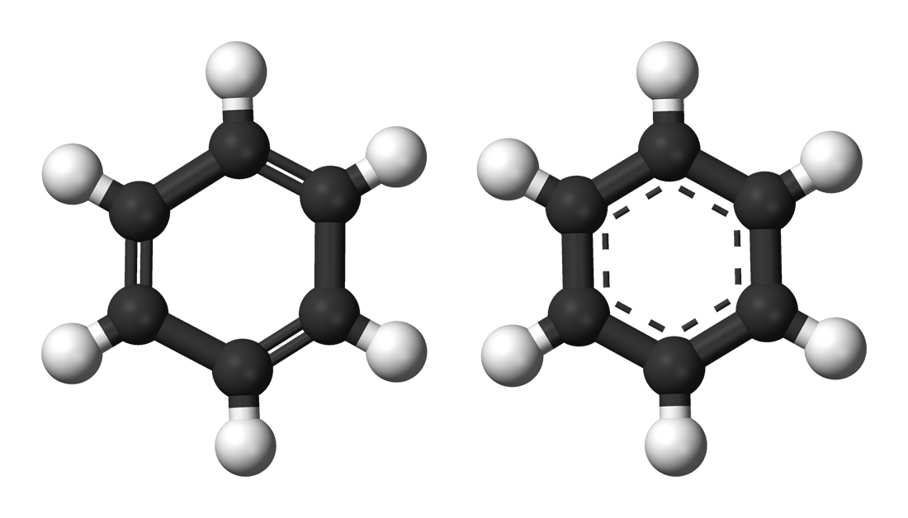

Aromatic Rules:
The three general requirements for a compound to be aromatic are:
- The compound must be cyclic
- Each element within the ring must have a p-orbital that is perpendicular to the ring, hence the molecule is planar.
- The compound must follow Hückel's Rule (the ring has to contain 4n+2 p-orbital electrons).

Importance of Aromaticity:
Aromaticity plays a major role in the field of biochemistry of all the living structures. The four kinds of aromatic amino acids called the histidine, tryptophan, phenylalanine, and the tyrosine serve as the 20 basic types of building-blocks of the proteins. Also, the 5 kinds of nucleotides naming adenine, cytosine, thymine, guanine, uracil make up the main sequence within the genetic code present in the DNA and also RNA and these are said to be aromatic purines and pyrimidines.

2-Hyperconjugation:
What is Hyperconjugation?
Hyperconjugation is the stabilizing interaction that results from the interaction of the electrons in a σ-bond (usually C-H or C-C) with an adjacent empty or partially filled p-orbital or a π-orbital to give an extended molecular orbital that increases the stability of the system.
In the formalism that separates bonds into σ and π types, Hyperconjugation is the interaction of σ-bonds (e.g. C-H, C-C, etc.) with a π network.
This interaction is customarily illustrated by contributing structures, e.g. for toluene (below), sometimes said to be an example of "heterovalent" or "sacrificial hyperconjugation", so named because the contributing structure contains one two-electron bond less than the normal Lewis formula for toluene.
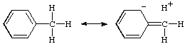
At present, there is no evidence for sacrificial hyperconjugation in neutral hydrocarbons.
The concept of hyperconjugation is also applied to carbenium ions and radicals, where the interaction is now between σ-bonds and an unfilled or partially filled π or p-orbital. A contributing structure illustrating this for the tert-butyl cation is:
This latter example is sometimes called an example of "isovalent hyperconjugation" (the contributing structure containing the same number of two-electron bonds as the normal Lewis formula).
Both structures are also examples of "double bond- no-bond resonance".
The interaction between filled π or p orbitals and adjacent antibonding σ* orbitals is referred to as "negative hyperconjugation", as for example in the fluoroethyl anion:
RADOM (1982).
3-Electrometric effect

Electrometric effect:
Electrometric effect is a temporary effect and observed only in organic compounds with multiple bonds in the presence of an attacking reagent.
Electrometric effect can be defined as the complete transfer of shared pair of pi electrons of multiple bonds to one of the atoms in presence of an attacking reagent.
Types of Electrometric Effects:
The electrometric effect can be broken down into two types, namely the +E effect and the -E effect. This classification is done based on the direction in which the electron pair is transferred.
+E Effect
This effect occurs when the electron pair of the pi bond is moved towards the attacking reagent. The +E effect can be observed in the addition of acid to alkenes. The attacking reagent attaches itself to the atom which obtained an electron pair in the transfer.
The +E effect is generally observed when the attacking reagent is an electrophile and the pi electrons are transferred towards the positively charged atom. An example where the +E effect occurs is the protonation of ethene which is illustrated below.
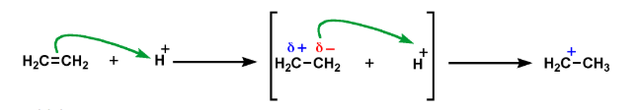
-E Effect
This effect occurs when the electron pair of the pi bond is moved away from the attacking reagent. The attacking reagent attaches itself to the positively charged atom in the molecule, i.e. the atom which lost the electron pair in the transfer.
The -E effect is generally observed when the attacking reagent is a nucleophile and the pi electrons are transferred to the atom which the attacking reagent will not bond with. An example where the -E effect occurs would be the addition of nucleophiles to carbonyl compounds as illustrated below.
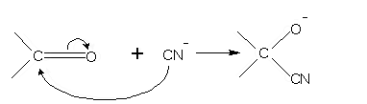

4-Hydrogen Bonding
Hydrogen bonding, interaction involving a hydrogen atom located between a pair of other atoms having a high affinity for electrons; such a bond is weaker than an ionic bond or covalent bond but stronger than van der Waals forces. Hydrogen bonds can exist between atoms in different molecules or in parts of the same molecule. One atom of the pair (the donor), generally a fluorine, nitrogen, or oxygen atom, is covalently bonded to a hydrogen atom (―FH, ―NH, or ―OH), whose electrons it shares unequally; its high electron affinity causes the hydrogen to take on a slight positive charge. The other atom of the pair, also typically F, N, or O, has an unshared electron pair, which gives it a slight negative charge. Mainly through electrostatic attraction, the donor atom effectively shares its hydrogen with the acceptor atom, forming a bond. Because of its extensive hydrogen bonding, water (H2O) is liquid over a far greater range of temperatures that would be expected for a molecule of its size. Water is also a good solvent for ionic compounds and many others because it readily forms hydrogen bonds with the solute.
Hydrogen bonding in alcohols:
An alcohol is an organic molecule containing an -OH group. Any molecule which has a hydrogen atom attached directly to an oxygen or a nitrogen is capable of hydrogen bonding. Such molecules will always have higher boiling points than similarly sized molecules which don't have an -O-H or an -N-H group. The hydrogen bonding makes the molecules "stickier", and more heat is necessary to separate them.
Ethanol, CH3CH2−O−HCH3CH2−O−H, and methoxymethane, CH3−O−CH3CH3−O−CH3, both have the same molecular formula, C2H6OC2H6O.
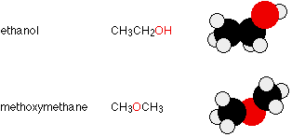
They have the same number of electrons, and a similar length to the molecule. The van der Waals attractions (both dispersion forces and dipole-dipole attractions) in each will be much the same. However, ethanol has a hydrogen atom attached directly to an oxygen - and that oxygen still has exactly the same two lone pairs as in a water molecule. Hydrogen bonding can occur between ethanol molecules, although not as effectively as in water. The hydrogen bonding is limited by the fact that there is only one hydrogen in each ethanol molecule with sufficient + charge.
In methoxymethane, the lone pairs on the oxygen are still there, but the hydrogen’s are not sufficiently + for hydrogen bonds to form. Except in some rather unusual cases, the hydrogen atom has to be attached directly to the very electronegative element for hydrogen bonding to occur. The boiling points of ethanol and methoxymethane show the dramatic effect that the hydrogen bonding has on the stickiness of the ethanol molecules:
Ethanol (with hydrogen bonding): 78.5°C
Methoxymethane (without hydrogen bonding): -24.8°
Why hydrogen bond occur?
Since the hydrogen donor is strongly electronegative, it pulls the covalently bonded electron pair closer to its nucleus, and away from the hydrogen atom. The hydrogen atom is then left with a partial positive charge, creating a dipole-dipole attraction between the hydrogen atom bonded to the donor, and the lone electron pair on the accepton. This results in a hydrogen bond.(see Interactions Between Molecules With Permanent Dipoles)
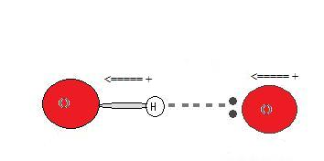

5-Tautomerism of Carbonyl compounds:

Tautomers are isomers of a compound which differ only in the position of the protons and electrons. The carbon skeleton of the compound is unchanged. A reaction which involves simple proton transfer in an intramolecular fashion is called a Tautomerism.
Keto-enol tautomerism is a very common process, and is acid or base catalyzed. Typically the 'keto' form of the compound is more stable, but in some instances the 'enol' form can be the more stable.
Some examples of Tautomerism:
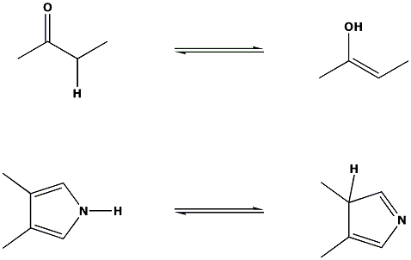
NOTE: The equilibrium arrows above do not intend to show the position of the equilibrium, only that an equilibrium exists between the two forms.

Tautomerism in aldehyde:
If an aldehyde possesses at least one hydrogen atom on the carbon atom adjacent to the carbonyl group, called the alpha (α) carbon, this hydrogen can migrate to the oxygen atom of the carbonyl group. The double bond then migrates to the α-carbon. As a result, a carbonyl compound with an α-hydrogen can exist in two isomeric forms, called tautomers. In the keto form, the hydrogen is bonded to the α-carbon, while in the enol form it is bonded to the carbonyl oxygen with the migration of the double bond

.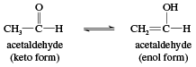

The name enol is derived from the IUPAC designation of it as both an alkene (-ene) and an alcohol (-ol). Keto and enol isomers exist in equilibrium in which both tautomers are present but, in simple cases, the keto form is much more stable than the enol form. In acetaldehyde, for example, only about 6 of every 10 million molecules are in the enol form at any given time. Nevertheless, the equilibrium always exists, and every molecule of acetaldehyde (as well as any other aldehyde or ketone with an α-hydrogen) is converted to the enol form (and back again) several times per second. This is an important characteristic because a number of reactions of carbonyl compounds take place only through the enol forms. Certain carbonyl compounds have a much higher percentage of its molecules in the enol form.

6-Stereoisomerism

Stereoisomers are isomers that have the same composition (that is, the same parts) but that differ in the orientation of those parts in space. Stereoisomers are molecules that have the same molecular formula and differ only in how their atoms are arranged in three-dimensional space.
Stereoisomers are molecules that have the same molecular formula and sequence of bonded atoms, but differ in the three-dimensional orientations of their atoms in space.

There are two kinds of stereoisomers: geometric and optical.
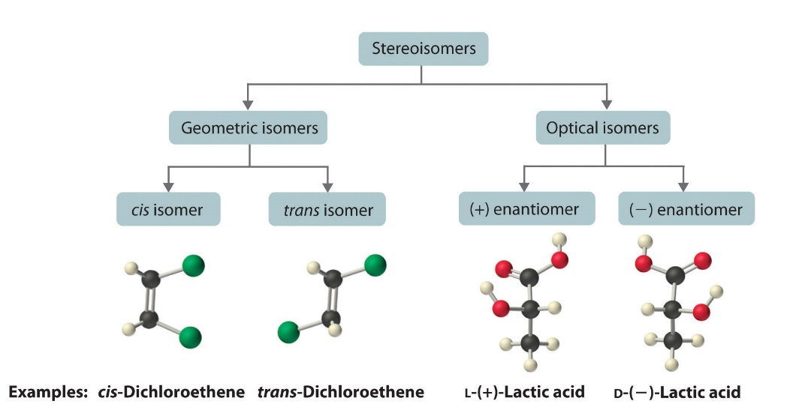
Geometric Isomers:
Geometric isomers differ in the relative positions of substituents in a rigid molecule.
For example, 1,2-dichloroethene can exist as the cis isomer, with both Cl atoms on the same side of the double bond, or as the trans isomer, with the Cl atoms on opposite sides of the double bond.
Cis and trans isomers have different physical and chemical properties.
Optical Isomers:
Optical isomers are molecules whose structures are mirror images that cannot be superimposed on one another in any orientation.
Such molecules are said to be chiral.
For example, D-lactic acid and L-lactic acid are optical isomers.
Optical isomers differ only in their interactions with polarized light and with other chiral molecules

